Student Habit & Performance Analysis Dashboard
Project Overview
This project analyzes students lifestyle and study habits to understand their impact on exam performance. The dataset includes factors like study hours, digital usage, sleep, exercise, caffeine intake, and mental health. Using Excel analysis, the project identifies patterns related to focus, burnout, productivity, and exam scores. The goal is to understand which habits help students perform better in exams.
Data Cleaning
The dataset was cleaned using steps such as removing duplicates, standardizing text format, replacing incorrect values, creating calculated columns, converting minutes to hours, and rounding numeric values.
Tool Used
- Microsoft Excel
- Power Query
- Pivot Tables
- Pivot Charts
- Dashboard Visualization
KPI Metrics
- Total Students: 5000
- HSC Students: 1672
- UG Students: 1641
- PG Students: 1687
- Female Students: 1630
- Male Students: 1719
- Other Gender Students: 1651
Key Insights
- Students who study more than 10 hours tend to achieve higher exam scores, showing a positive relationship between study time and performance.
- As digital screen time increases, the exam score gradually decreases. High digital usage may negatively affect academic performance.
- Students with low burnout show higher productivity and exam scores, while high burnout students have lower focus and productivity.
- Students who sleep 7–8 hours or more show better focus and higher productivity compared to students with lower sleep duration.
- The dashboard shows slight differences in exam performance across gender groups, but performance trends remain relatively similar.
- Around 57% of students fall in the middle burnout category, 39% in high burnout, and 3% in low burnout, indicating many students experience moderate stress levels.
- Students with deadlines and part-time work tend to show higher burnout levels and lower exam scores compared to those without deadlines.

Dashboard
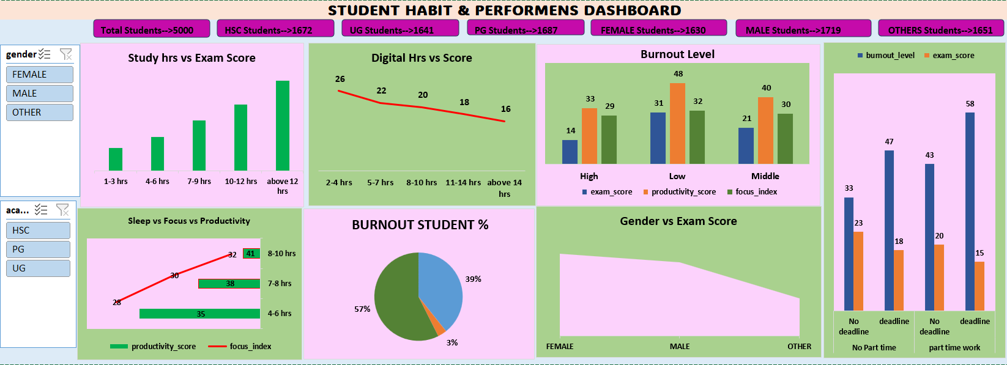

Conclusion
This project analyses how student lifestyle habits affect academic performance. The analysis shows that study hours, digital usage, sleep patterns, and burnout levels have a strong influence on exam scores. Students who maintain balanced study time, moderate digital usage, proper sleep, and low burnout levels tend to achieve better focus, productivity, and higher exam performance. The dashboard helps visualize these relationships and provides useful insights into student behavior.

